2014 – 2017 Co-Teaching Program
2017
- 2017.12.11 Dr. Park from USC visit the Department of Occupational Therapy
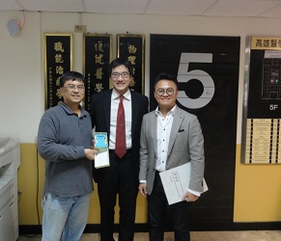
- 2017.11.15-11.17 Dr. Ming-Chung Chou, chairman of Department of Medical Imaging and Radiological Sciences, invited Prof. Tamotsu Kamishima for international collaborative teaching activity.
- 2017.09.18-09.20 Professor Masafumi Mizukami(Vice-Chancellor of Ibaraki University, Japan) visited the Department of Physical Therapy and gave talks to MSc and BSc students.
- 2017.09.18-09.20Professor Yasutsugu Asakawa(Department of Physical Therapy, Ibaraki University, Japan) visited the Department of Physical Therapy and gave talks to MSc and BSc students.
- 2017.09.18-09.22Department of Medical Imaging and Radiological Sciences received distinguished professors from Ibaraki Prefectural University of Health Sciences, and arranged the visiting of teaching facilities and hospitals.
- 2017.07.07 Dr Shih-fen Hsiao served as invited speaker in the ‘3rd FHS International Conference: Hitch Our Wagon to A Remedy’ held by the Faculty of Health Sciences, Hokkaido University, Japan.
- 2017.06.08-06.10 Professor Tetsuya Takahashi (Vice Dean of School of Health Sciences and Head, Department of Physical Therapy, Tokyo University of Technology, Japan) visited the Department of Physical Therapy and gave talks to MSc and BSc students.
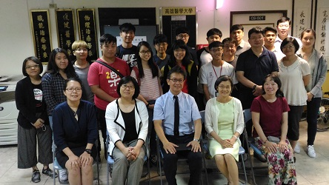
- 2017.05.17-18 Co-teaching
May 17 (W3; 3-5pm) Picornavirus ; Noraviruses, Reovirus
May 18 (W4; 8-12am) Antibiotic susceptibility test (laboratory)

2016
- 2016.12.26-29 Dr Mina Samukawa from Division of Rehabilitation Sciences, Hokkaido University, Japan. Host: Department of Physical Therapy
- 2016.11.19 Yoshikuni Sei from Japan. Topics: Introduction of the Application of PNF on hemiplegic adults. Host: Department of Physical Therapy
- 2016.11.04 Dr. Schell from Brenau University, USA. Topics: (1) Situated Learning Theories & Communities of Practice (2) Occupation-based practice…。Host: Department of Occupational Therapy
- 2016.10.31-11.02 Dr. Marc Potvin from Canada. Topics: (1)Introduction of Michener Institute at UHN (2) Image-guided Radiation Therapy (3)Volumetric Modulated Arc Therapy. Host: Department of Medical Imaging and Radiological Sciences
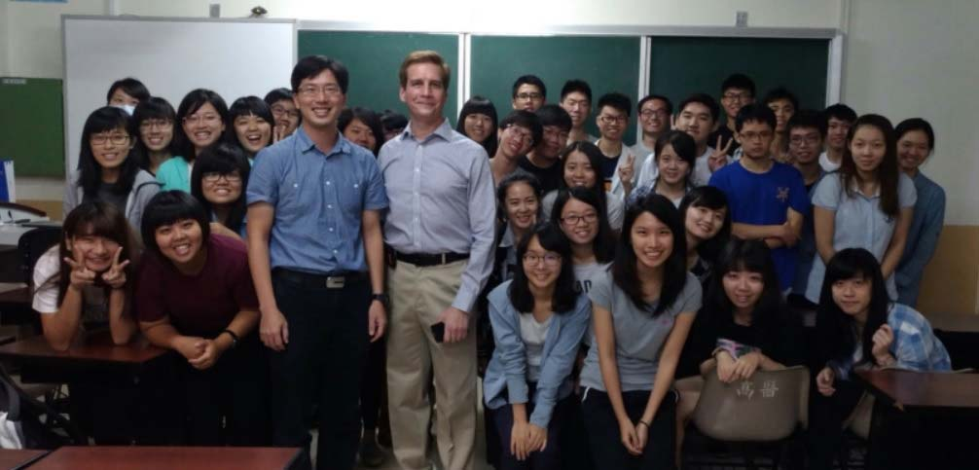
- 2016.10.11 William Goggins from Chinese University of Hong Kong. Topics: Urban design characteristics, ambient temperatures and mortality in Kaohsiung and Hong Kong. Host: Department of Public Health
- 2016.09.26-09.28 Dr. Okuno from IPU. Topics: Cardiopulmonary Physical Therapy in Japan
Host: Department of Physical Therapy.
- 2016.09.27 Masahiko Monma from Ibaraki Prefectural University of Health Sciences, Japan.
Topics: Introduction of Department of Radiological Sciences in Ibaraki Prefectural University of Health Sciences. Host: Department of Medical Imaging and Radiological Sciences
- 2016.04.25~28 Peter Chang from Hong Kong University. Topics: Probiotics. Host: Department of Medical Laboratory Science and Biotechnology
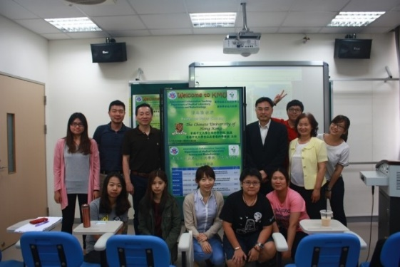
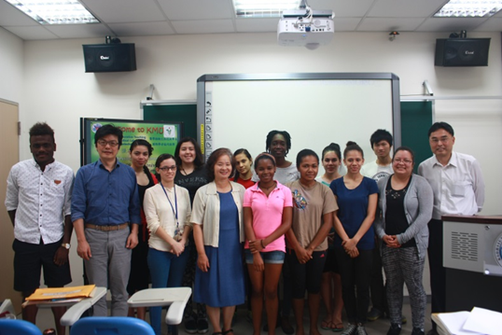
- 2016.04.12 Prof. Jürgen Hennig (University of Freiburg, Germany). Topic: Basic and Advanced Concepts of Magnetic Resonance Imaging. Host: Department of Medical Imaging and Radiological Sciences
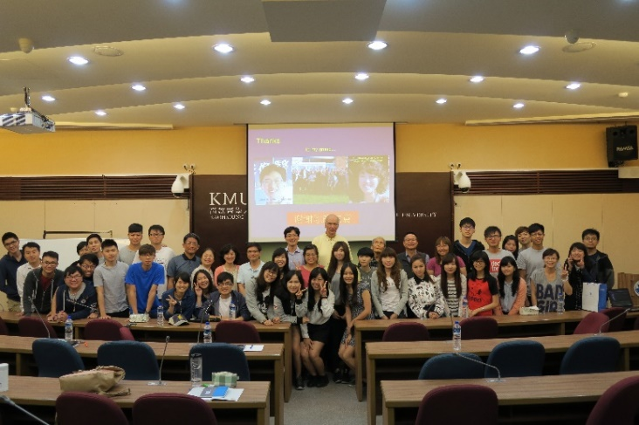

2015
- 2015.12.23~25 Dr. Shinya Sakai (Hokkaido University, Japan)
Topic: Rehabilitation of visual disorders after brain injury; Occupational therapy for children with spinal muscular atrophy type I; Visual assessment and rehabilitation for children with cerebral visual impairment
Host: Department of Occupational Therapy
- 2015.12.23-25 Dr. Kaori Tsutsumi (Hokkaido University, Japan)
Topic: Basics, Clinical Applications and Researches in Radiobiology
Host: Department of Medical Imaging and Radiological Sciences.
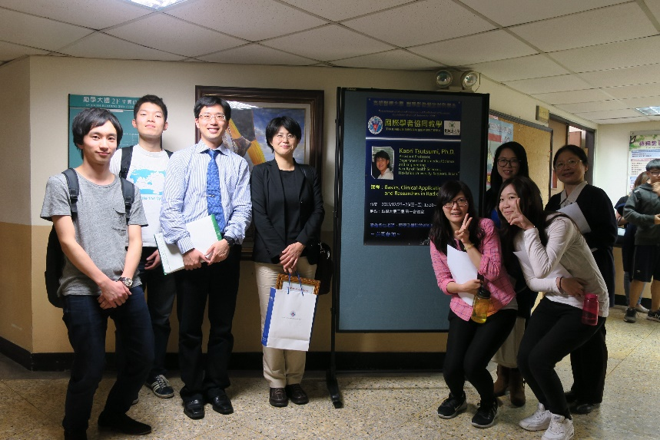
- 2015.12.18-27Prof. Thomas T. H. Wan（College of Health and Public Affairs, University of Central Florida）. Topic: Special Topics in Research Methods of Healthcare Administration
Host: Department of Healthcare Administration and Medical Informatics
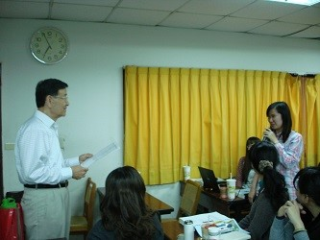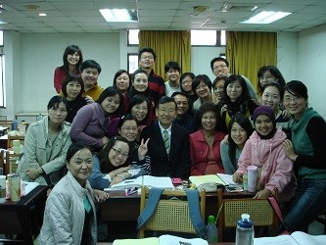
- 2015.12.08~09 Dr. Monica Ann Pessina (Boston University, USA)
Topic: Rehabilitation after Burn Injuries; Acute hand burns: management and long-term outcome
Host: Department of Occupational Therapy
- 2015.10.28, 2015.10.30 Prof. Kazushi MOTOMURA (Thailand-Japan Research Collaboration Center on Emerging and Re-emerging Infections, Osaka University)
Topic: DNA recombination and expression proteins in using cloning experiment
Topic: Application research using new generation sequencer
Host: Department of Medical Imaging and Radiological Sciences
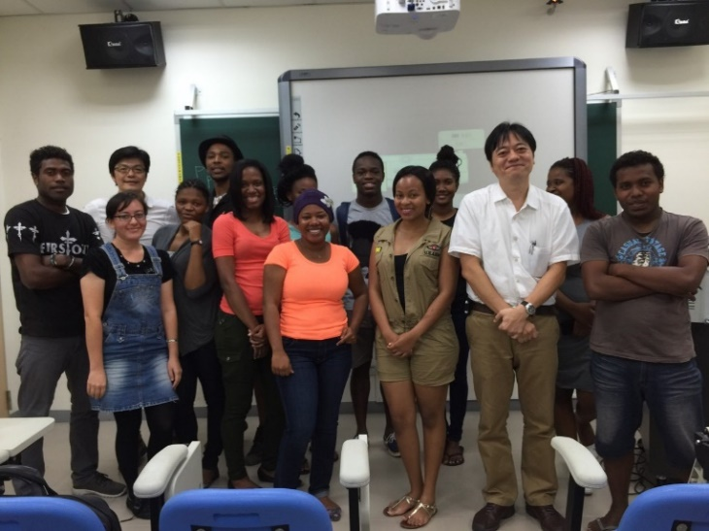
- 2015.07.02 Assistant Prof. Shih-Fen Hsiao (Kaohsiung Medical University, Taiwan)
Host: Department of Physical Therapy, Hokkaido University
- 2015.03.27-29 Prof. Tadayoshi Asaka and research team (Hokkaido University, Japan)
Topic: The Mechanisms and clinical applications of postural control, Living environmental design for Japanese elderly and disabilities.
Host: Department of Physical Therapy, Master Degree Program in Aging and Long-Term Care

2014
- 2014.12.16-18 Dr. Seiji Kumazawa (Kyushu University, Japan)
Topic: Basics, Acquisition, and Application of diffusion MRI
Host: Department of Medical Imaging and Radiological Sciences
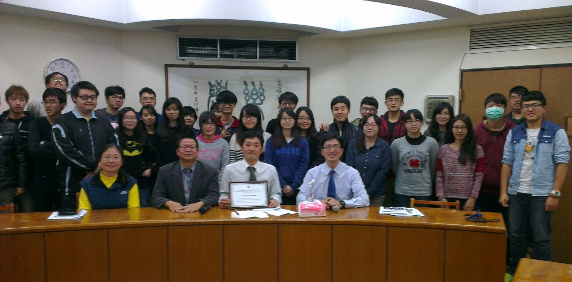
- 2014.10.20~23 Dr. Frank Kronenberg (University of Cape, South Africa)
Topic: Occupation therapy without border
Host: Department of Occupational Therapy

2013
- 2013.10.28~30 Dr. Louise Farnworth (Monash University, Australia)
Topic: Occupational Science and occupation-based practices: The Australian context
Host: Department of Occupational Therapy
- 2013.10.23-25. Pro. Toshiaki Muraki (Ibaraki Prefectural University, Japan)
Topic: Occupational Therapy in Productive Aging; Dementia and the Role of Occupational Therapy; Occupational therapy fieldwork in Japan
Host: Department of Occupational Therapy
- 2013.03.30 Assistant Prof. Shih-Fen Hsiao (Kaohsiung Medical University, Taiwan) and Prof. Tadayoshi Asaka and research team (Hokkaido University, Japan)
Topic: 「Postural control」conference
Host: Faculty of Health Sciences, Hokkaido University
- 2013.03.03~06. Dr. Eric Asaba(Karolinska Institutet, Stockholm, Sweden)
Topic: Reflections about a qualitative paradigm; Narrative as analysis; Participatory method
Host: Department of Occupational Therapy

